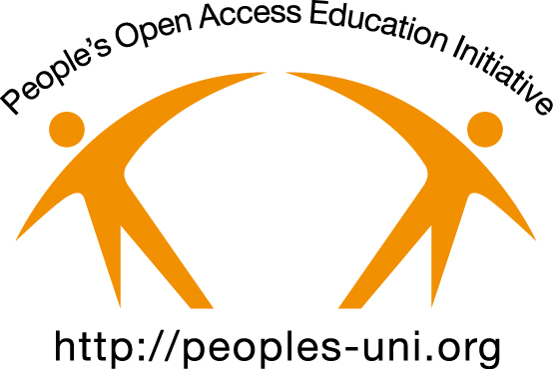
Background and Partnerships

The development of People's Open Access Education Initiative (Peoples-uni http://peoples-uni.org) was coordinated by Professor Dick Heller, who had just retired as Professor of Public Health from the University of Manchester, where he had established that University's first online Masters course, and the UK's first fully online Masters Course in Public Health. Situation analyses were performed in a number of developing countries, which indicated a major need for affordable and high quality Masters level courses in Public Health. Curriculum development was initially undertaken by a small group, with advice from the education team at the UK Royal Society for Public Health, our first partner organisation, and leaned heavily on the experience of the programme at the University of Manchester.

A validation process was undertaken with Manchester Metropolitan University (MMU), including extensive and detailed discussions with the QA team, and a number of changes were made to the structure of the units and methods of assessment to ensure that the programme was benchmarked at the requisite standard for a UK Level 7 (Masters) degree. As part of the validation exercise, external experts joined MMU staff, and gave their input, and then approval of the programme. Following this, students who passed at least two modules in Peoples-uni became eligible to enrol as external students on an MMU MPH programme, with all education, assessment and infrastructure provided by Peoples-uni.

People's Open Access Educational Initiative - Peoples-uni - has been registered as a UK Charity (No:1126265) since 2007. The Trustees include Professor Rajan Madhok (Chair), Dr Selwyn Hodge, Mr Alec Tice (Treasurer), Ms Maggie Davies, and Professor Dick Heller (Coordinator of the Peoples-uni). The programme is delivered 100% fully online. The use of Open Educational Resources and a volunteer staff, allows us to offer the education at very low cost so that it is affordable to people in developing countries. The tutors delivering this programme work in more than 20 countries, and range from Public Health Trainees (post-MPH) in the Faculty of Public Health training programme, through Public Health specialists and consultants, researchers and academics to the professorial level. Of the 126 currently active tutors, 23 are at the Associate Professor or Professor level at universities - mostly in the UK or Australia. A few of the teachers are retired, but the majority are in current employment. All the learning material, administration process, marketing material and enrolment process are within Peoples-uni. To date, more than 1000 students from more than 40 countries, have registered for courses through Peoples-uni and 124 of these so far have enrolled on the MMU MPH programme with 30 graduates (and a further 20 due to graduate this semester).
An IT group underpins the delivery of courses through the Moodle platform and has developed the associated automated application, enrolment and student progress spreadsheets for record keeping.

Partnership with Universities.
We are seeking partnership with Universities to allow us to offer credible academic awards to our students and to develop further programmes and collaborations. A partner University might approve a similar validation process as that with MMU (whose partnership is being terminated by mutual agreement). This could be for the MPH programme, or for other academic awards such as Graduate Certificate programmes in areas of special interest – for example we have plans for Graduate Certificate programmes in Patient Safety, Chronic Disease interventions, Evaluation of Interventions, and Scientific Decision Making in health Care.

In terms of potential risks for a partner University. Firstly, in terms of the risks associated with the reliance of PU to develop and upkeep of content, delivery of teaching and involvement of student support, it should be noted that there has never been a situation where courses could not run in any of the semesters since the first one in 2008. There are a number of strategies in place by Peoples-uni to ensure stability and continuity, including having 17 units on offer, with only 6 being needed, together with the Dissertation, for the award of the MPH. Secondly, it is recognised that this organisation is run on goodwill and on a voluntary basis. Volunteers do drop out for family or professional reasons, but there is a constant stream of new tutors who arrive through their initiative in making contact through the web site or personal contacts with current staff. Graduates of the programme are also beginning to join the teaching staff – which has many benefits. The Manchester Centre for Global Health Volunteering has adopted Peoples-uni as its public health capacity building partner. Thirdly, in terms of finances, Peoples-uni is now a financially viable organisation especially as its costs are very low and it is able to raise sufficient funds through the fees to meet its ongoing commitments. It is currently exploring options for raising further revenue, whilst keeping its principle of low fees for students. Finally, in terms of reputational risk to any Partnering University, due diligence at the start and ongoing reviews will mitigate against any significant challenges. In any case, Peoples-uni has been running for many years now and is seen as a credible organisation globally.

Peoples-uni recognises the current environment and the need for a viable business case for any potential partner. In addition to meeting the costs of student enrolments and QA, Peoples-uni will aim to work with the Partner to explore research and further educational opportunities that may develop. The benefits of partnership to a partner University might include the reputational rewards of contributing to capacity building in developing countries, linkages with other organisations at home and overseas and through graduates for collaborative research and educational opportunities, input on online educational technology and methods, and a continuing source of PhD students. In addition, the partner University might want to add some of the programmes run through Peoples-uni to their own offerings either to broaden the scope of what they offer in terms of content area or the online mode of delivery.

It should be stressed that there is no call on the partner University for infrastructure – all is provided through Peoples-uni. A basic minimum is the provision of a QA function and the paperwork associated with that and the award of the partner University's awards. However, we would hope that a Partner University will also share our goals for health improvement in developing countries and explore collaborative opportunities together.

